Demonstrate the Pandas DataFrame? Creating DataFrame using a List?
Pandas DataFrame

A Pandas DataFrame is a two-dimensional table-like structure in Python where data is arranged in rows and columns. It’s one of the most commonly used tools for handling data and makes it easy to organize, analyze and manipulate data. It can store different types of data such as numbers, text and dates across its columns. The main parts of a DataFrame are:
- Data: Actual values in the table.
- Rows: Labels that identify each row.
- Columns: Labels that define each data category.
In this article, we’ll see the key components of a DataFrame and see how to work with it to make data analysis easier and more efficient.
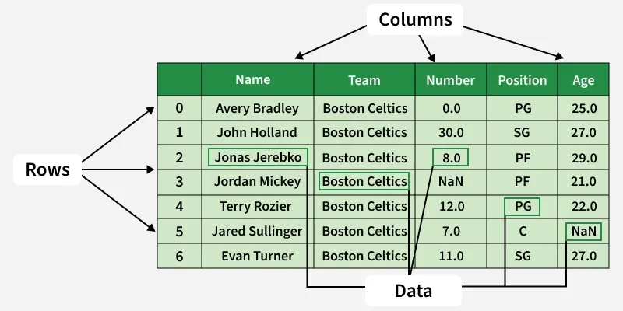

Creating a Pandas DataFrame
Pandas allows us to create a DataFrame from many data sources. We can create DataFrames directly from Python objects like lists and dictionaries or by reading data from external files like CSV, Excel or SQL databases.
Here are some ways by which we create a dataframe:
1. Creating DataFrame using a List
If we have a simple list of data, we can easily create a DataFrame by passing that list to the pd.DataFrame() function.
import pandas as pd

lst = ['Geeks', 'For', 'Geeks', 'is',
'portal', 'for', 'Geeks']

df = pd.DataFrame(lst)
print(df)

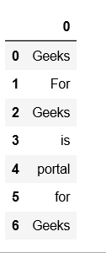

Creating DataFrame from dict of ndarray/lists
We can create a DataFrame from a dictionary where the keys are column names and the values are lists or arrays.
- All arrays/lists must have the same length.
- If an index is provided, it must match the length of the arrays.
- If no index is provided, Pandas will use a default range index (0, 1, 2, …).
import pandas as pd

data = {'Name':['Tom', 'nick', 'krish', 'jack'],
'Age':[20, 21, 19, 18]}

df = pd.DataFrame(data)

print(df)

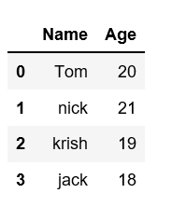

Illustrate the Pandas Series in python? Explain various key futures in panda series?

Python Pandas Series
Pandas Series is a one-dimensional labeled array that can hold data of any type (integer, float, string, Python objects, etc.). It is similar to a column in an Excel spreadsheet or a database table. In this article we will study Pandas Series which is a useful one-dimensional data structure in Python.
Key Features of Pandas Series:
- Supports integer-based and label-based indexing.
- Stores heterogeneous data types.
- Offers a variety of built-in methods for data manipulation and analysis.
Creating a Pandas Series
A Pandas Series can be created from different data structures such as lists, NumPy arrays, dictionaries or scalar value.
import pandas as pd

data = [1, 2, 3, 4]

ser = pd.Series(data)
print(ser)

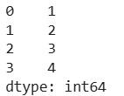

The numbers on the left (0, 1, 2, 3) represent the index which is automatically assigned by Pandas. The values (10, 20, 30, 40) represent the data stored in the Series
Accessing elements of Series
In Pandas we can access element of series using two ways:
- Position-based Indexing - In this we use numerical positions similar to lists in Python.
- Label-based Indexing - This method also custom index labels assigned to elements.
1. Position-based Indexing
In order to access the series element refers to the index number. Use the index operator []to access an element in a series. The index must be an integer. In order to access multiple elements from a series we use Slice operation
import pandas as pd
import numpy as np

data = np.array(['g','e','e','k','s','f', 'o','r','g','e','e','k','s'])
ser = pd.Series(data)

print(ser[:5])

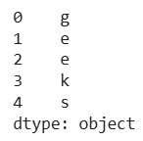

This prints the first five elements of the Series. The index is the default integer index starting from 0. So ser[:5] returns values from index 0 to 4 i.e., 5 elements in total.
Label-based Indexing
In order to access an element from series, we have to set values by index label. A Series is like a fixed-size dictionary in that we can get and set values by index label. let's see a example to understand this
import pandas as pd
import numpy as np
​
data = np.array(['g','e','e','k','s','f', 'o','r','g','e','e','k','s'])
ser = pd.Series(data,index=[10,11,12,13,14,15,16,17,18,19,20,21,22])
​
print(ser[16])
output: 0
The value at index label 16 is "o" because in our custom index label 16 corresponds to the 7th item in the array data which is 'o

Define NumPy? Why is NumPy Faster Than Lists?

NumPy(Numerical Python) is a fundamental library for Python numerical computing. It provides efficient multi-dimensional array objects and various mathematical functions for handling large datasets making it a critical tool for professionals in fields that require heavy computation.
NumPy has various features that make it popular over lists:
- N-Dimensional Arrays: NumPy's core feature is ndarray, a N-dimensional array object that supports homogeneous data types.
- Arrays with High Performance: Arrays are stored in contiguous memory locations, enabling faster computations than Python lists.
- Broadcasting: allows element-wise computations between arrays of different shapes. It simplifies operations on arrays of various shapes by automatically aligning their dimensions without creating new data.
- Vectorization: Eliminates the need for explicit loops by applying operations directly on entire arrays.
- Linear algebra: NumPy contains routines for linear algebra operations, such as matrix multiplication, decompositions and determinants.

NumPy Arrays are faster than Python Lists because of the following reasons:
- An array is a collection of homogeneous data-types that are stored in contiguous memory locations. On the other hand, a list in Python is a collection of heterogeneous data types stored in non-contiguous memory locations.
- The NumPy package breaks down a task into multiple fragments and then processes all the fragments parallelly.
- The NumPy package integrates C, C++, and Fortran codes in Python. These programming languages have very little execution time compared to Python.

Explain the Array operation in Numpy?

NumPy is a Python package which means 'Numerical Python'. It is the library for logical computing, which contains a powerful n-dimensional array object, gives tools to integrate C, C++ and so on. It is likewise helpful in linear based math, arbitrary number capacity and so on. NumPy exhibits can likewise be utilized as an effective multi-dimensional compartment for generic data. NumPy Array: Numpy array is a powerful N-dimensional array object which is in the form of rows and columns. We can initialize NumPy arrays from nested Python lists and access it elements. A Numpy array on a structural level is made up of a combination of:
- The Data pointer indicates the memory address of the first byte in the array.
- The Data type or dtype pointer describes the kind of elements that are contained within the array.
- The shape indicates the shape of the array.
- The strides are the number of bytes that should be skipped in memory to go to the next element.
Operations on Numpy Array
Arithmetic Operations:
# Python code to perform arithmetic
# operations on NumPy array
​
​
import numpy as np
​
​
# Initializing the array
arr1 = np.arange(4, dtype = np.float_).reshape(2, 2)
​
print('First array:')
print(arr1)
​
print('\nSecond array:')
arr2 = np.array([12, 12])
print(arr2)
​
print('\nAdding the two arrays:')
print(np.add(arr1, arr2))
​
print('\nSubtracting the two arrays:')
print(np.subtract(arr1, arr2))
​
print('\nMultiplying the two arrays:')
print(np.multiply(arr1, arr2))
​
print('\nDividing the two arrays:')
print(np.divide(arr1, arr2))
Output:
First array:
[[ 0. 1.]
[ 2. 3.]]

Second array:
[12 12]

Adding the two arrays:
[[ 12. 13.]
[ 14. 15.]]

Subtracting the two arrays:
[[-12. -11.]
[-10. -9.]]

Multiplying the two arrays:
[[ 0. 12.]
[ 24. 36.]]

Dividing the two arrays:
[[ 0. 0.08333333]
[ 0.16666667 0.25 ]]

